

American International University- Bangladesh

CSC 3222: Web Technologies

Course Teacher: Md. Al-Amin

CO1.1 and CO2.1 Evaluation

Project Report

Spring 21-22

Project Title: Travel & Tourism

Section: G

|  |  |
| --- | --- |
| Student Name | Student Id |
| 18-39140-3 | SHAHRIAR FARABI |
| 19-39538-1 | API ADHIKARY |
| 19-40538-1 | B.M. MAHIR SHAHRIAR |
| 19-40913-2 | MIR MONJUR MORSHED |

**Introduction:**

This project is being carried out to create a web application for all kinds of tours and travels. This application will save precious time as it can be used from the comfort of any places. User can view/book/cancel their all from one place. The company also get these benefits in organizing their tourism and also get report on the business report.

**Background Study:**

Above links inspired and drove this project towards its goal delivering principal ideas. These websites lead to create a web application where a user can register and then login to view/book/cancel of their desired tour plan to their desired location all from a single place. Also, there will be a staff for each tour plan who can add/update/remove bookings and view all the bookings that are booked and get a report on all the seat that that are sold which will help them maximize their profit.

.

**Requirement Analysis:**

1. **User Category:**

There are 4-types of Users here. They are:

* Admin
* Customer
* Manager
* Staff

1. **Feature List:**

In this project the “Admin” has the following features:

* Add, Delete, Update Customer
* Add, Delete, Update Manager
* Add, Delete, Update Staff
* View employee attendance
* Access to review booking reports
* Access to maintain tour schedules
* Access to customer reports and reviews
* Provide task via message
* Upload notice for all employees
* Upload news post for customers in our homepage

In this project the “Customer” has the following features:

* Customer register to the system
* Customer manipulate their profile information (edit-delete-view etc.)
* Customer can use promo code to get discount on package
* Customer can book packages
* Customer can check packages
* Customer can check services
* Customer can view gallery
* Customer can give review
* Customer can buy product/ can make a payment
* Customer can comment or provide review etc....

In this project the “Manager” has the following features:

* Access to update staff information
* Access to update members information
* Access to available deals
* Access to customize booking
* Access to booking rejection
* Access to sales account
* Access to notification system
* Access to contact with Admin
* Access to booking History
* Access to members reports and reviews

In this project the “Staff” has the following features:

* Staff can update their information through online
* Staff can see the customer review or comment and reply it
* Staff can have seen all kind of customers transaction with our company
* Staff can see customer information
* Staff can contact customer
* Staff can update customer info
* Staff can view or confirm customers booking
* Staff can have a notification system
* Staff can see the gallery through his profile
* Staff can see customer history with our company

**Design:**

Entity diagram of our project:

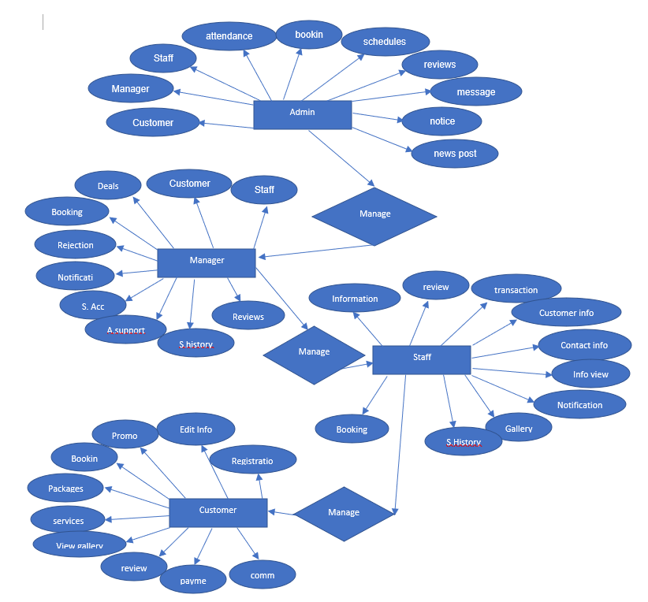

**Tools Used**:

To develop this project, we have used the following:

• Sublime Text

• Notepad

• Adobe Photoshop

• XAMPP

• Visual studio code

• Notepad++

• Chrome/Edge browser

• Microsoft word

**System Images against the Specification:**

Give a screen shot of some GUIs (Midterm project) and write a very small description (Maximum 40 words) for each of the GUIs.

**Admin:**

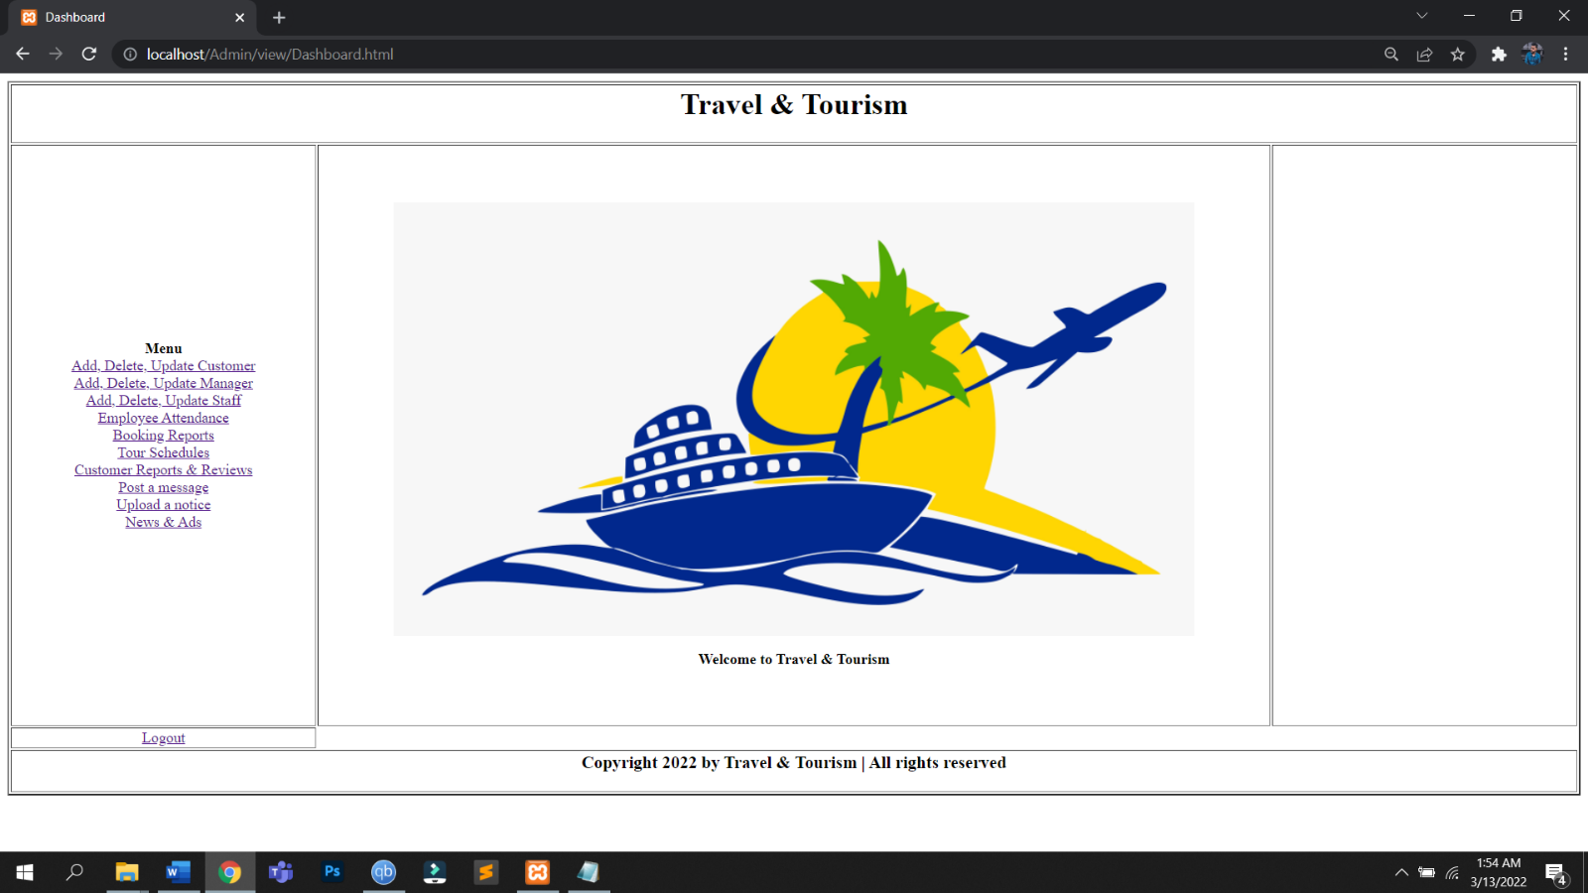

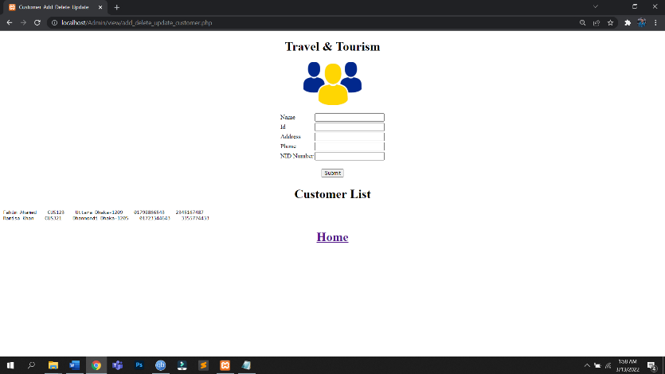

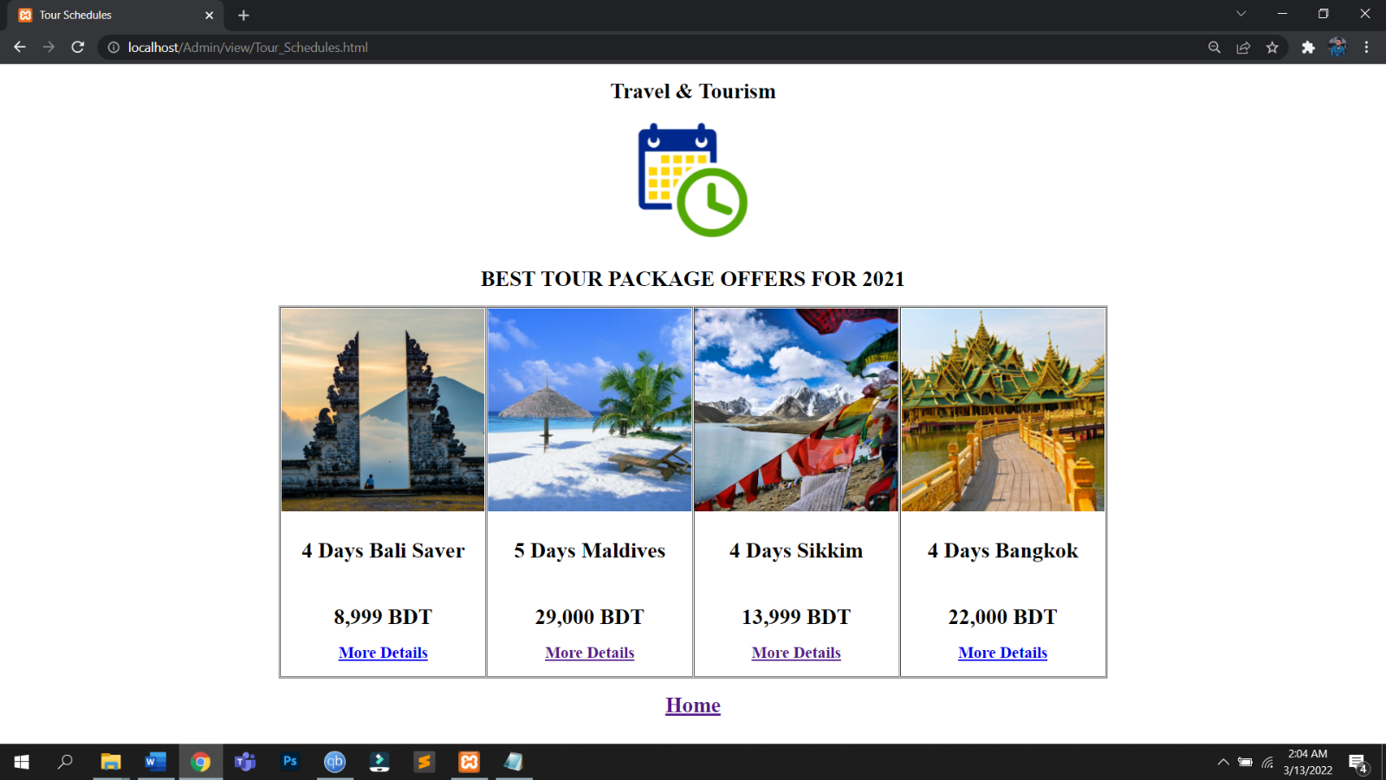

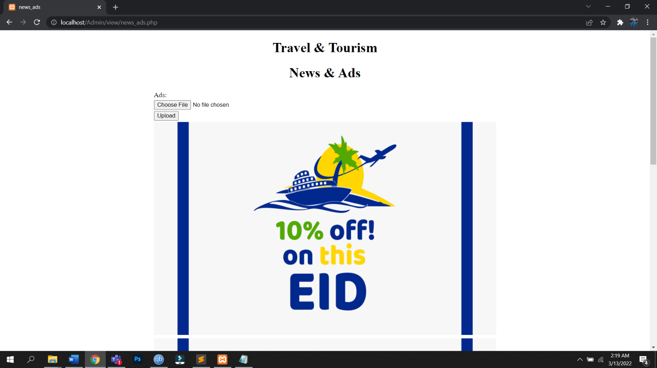

**Customer:** 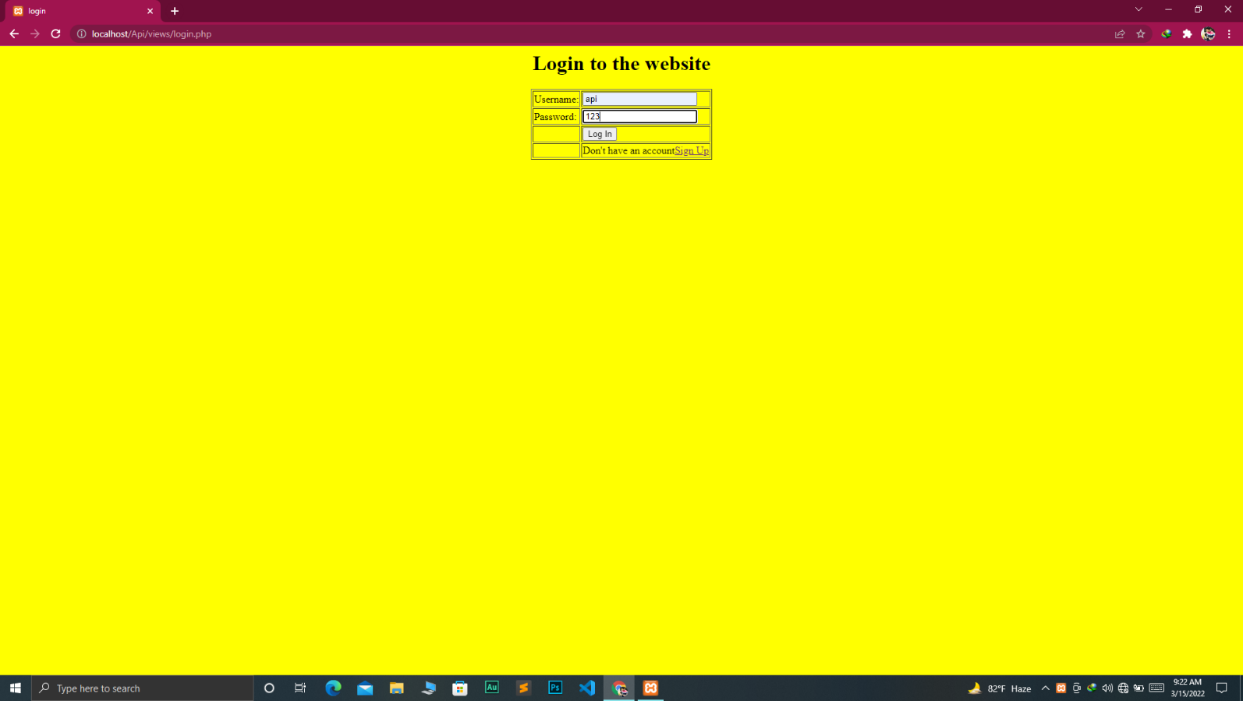

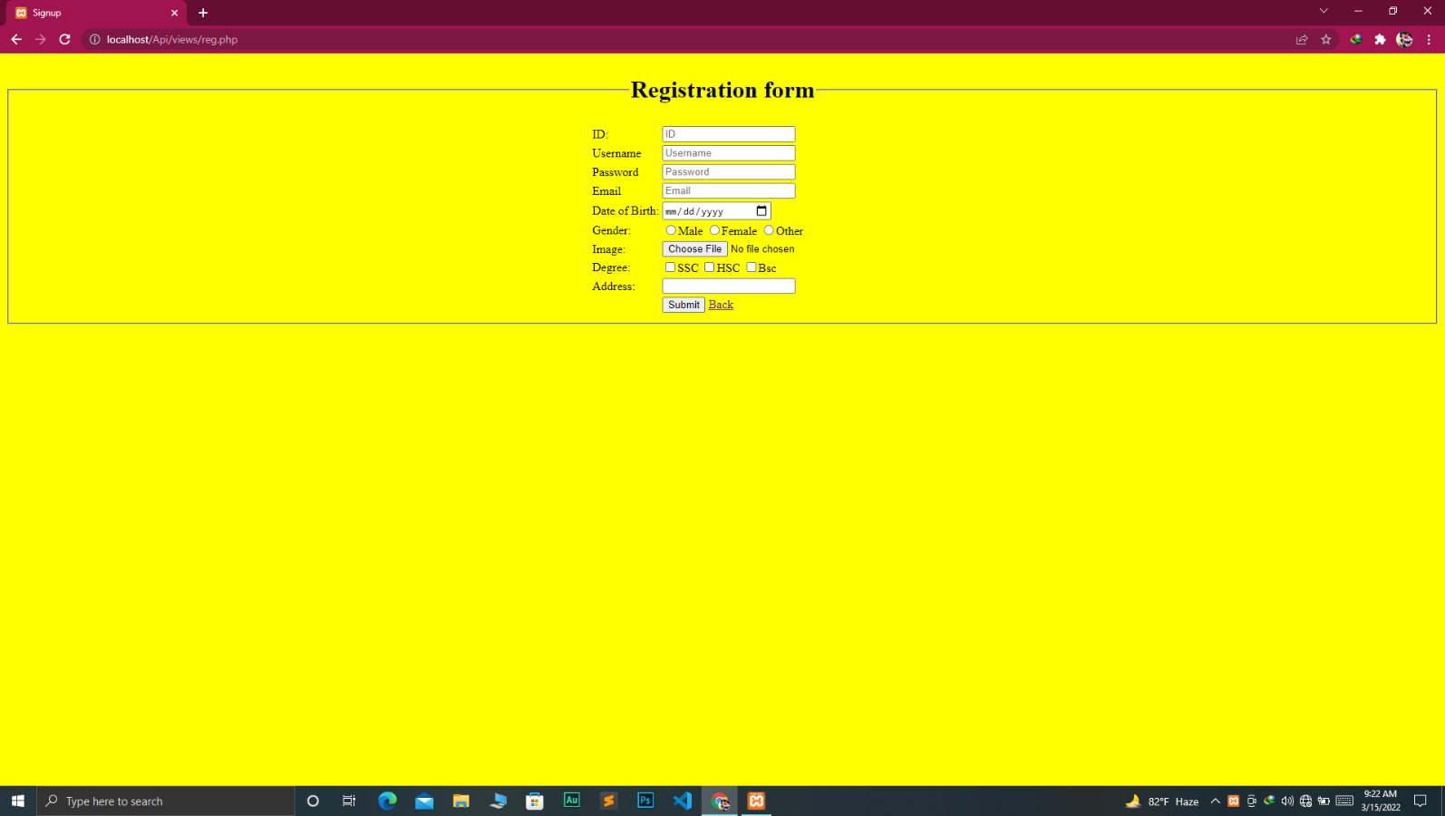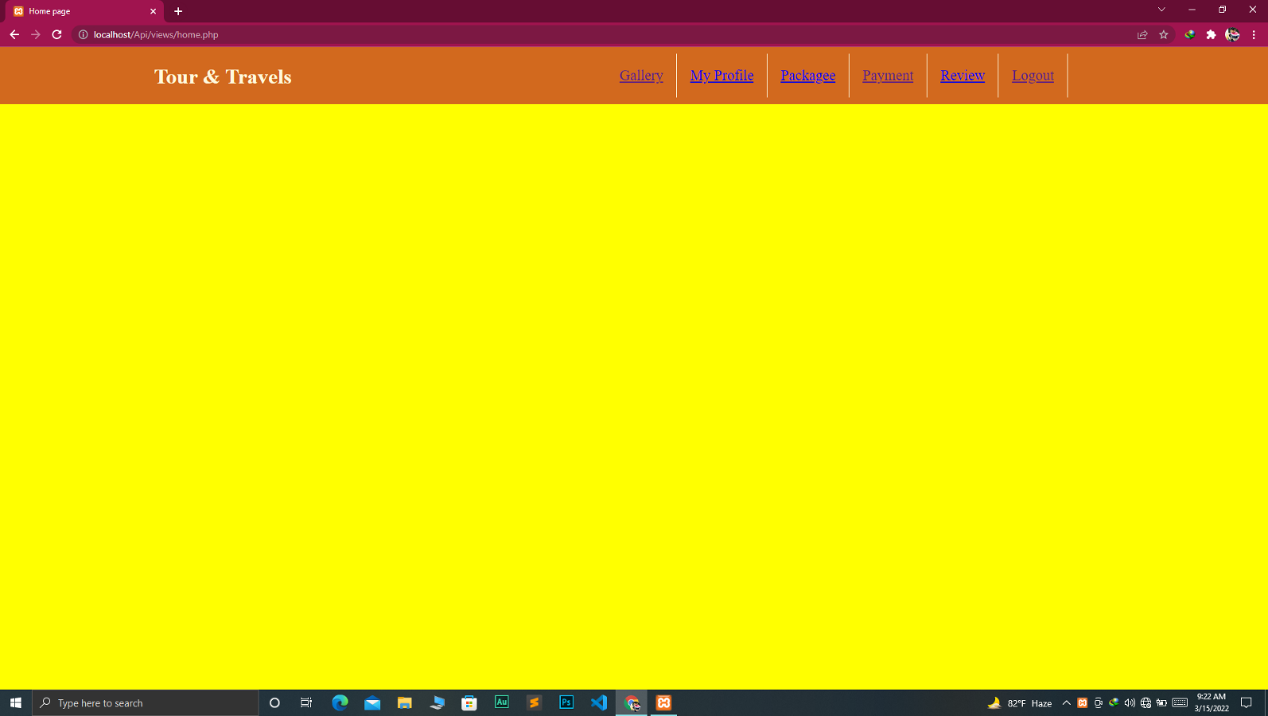

**Manager:**

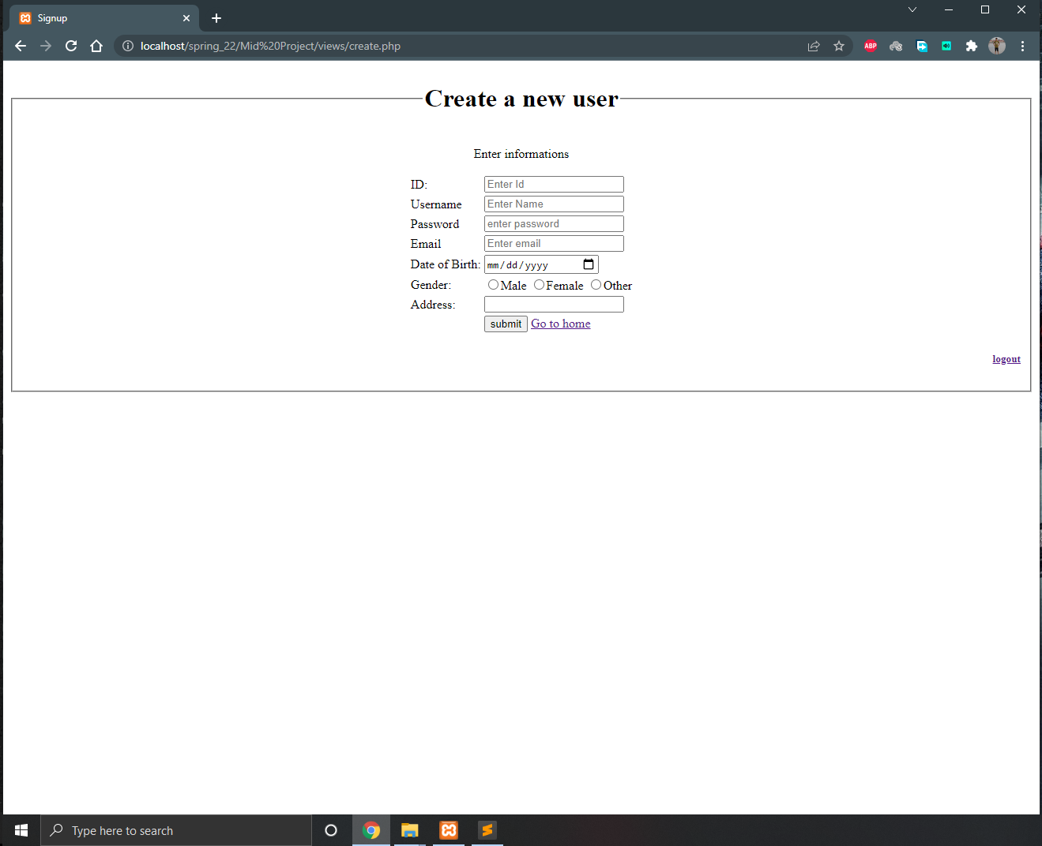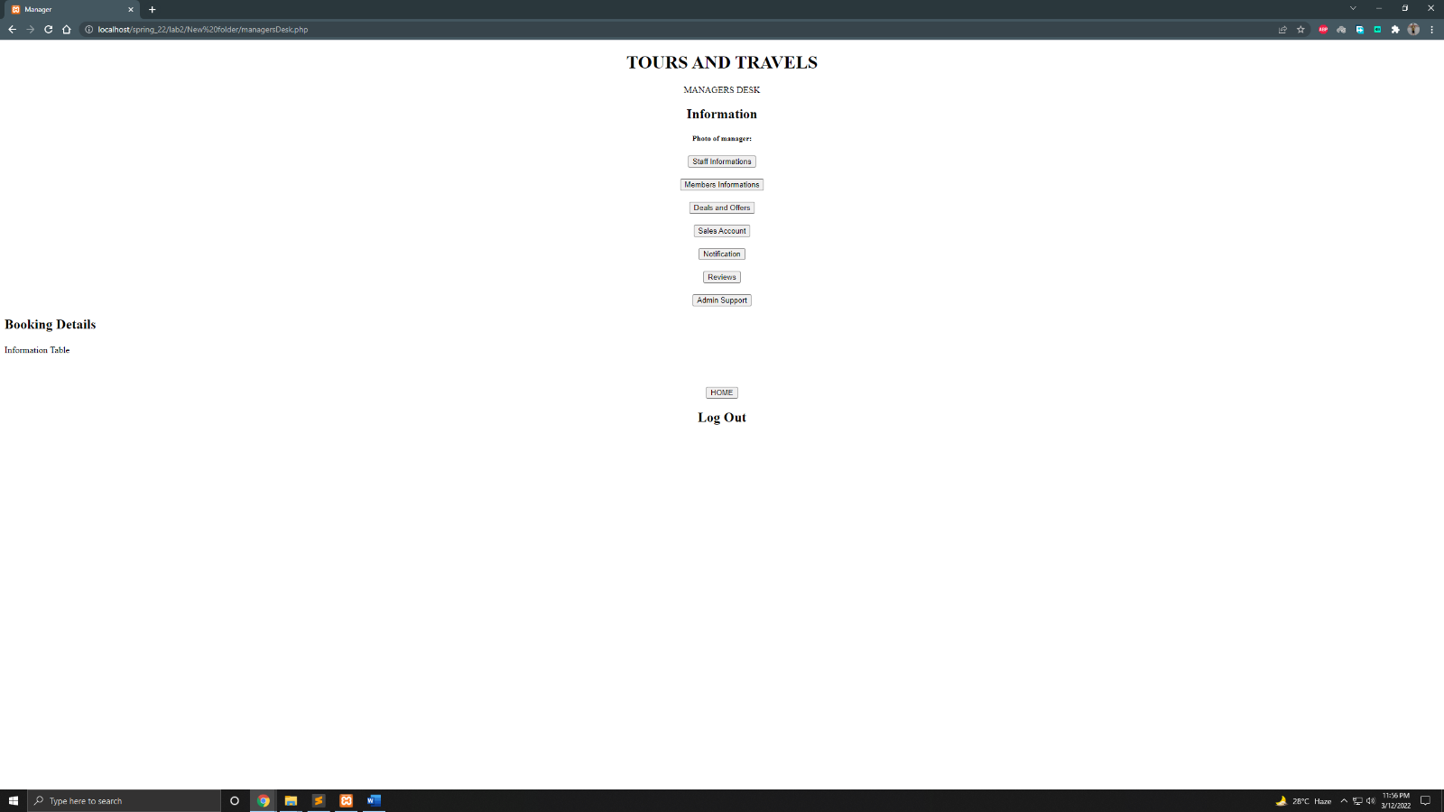

**Staff:**

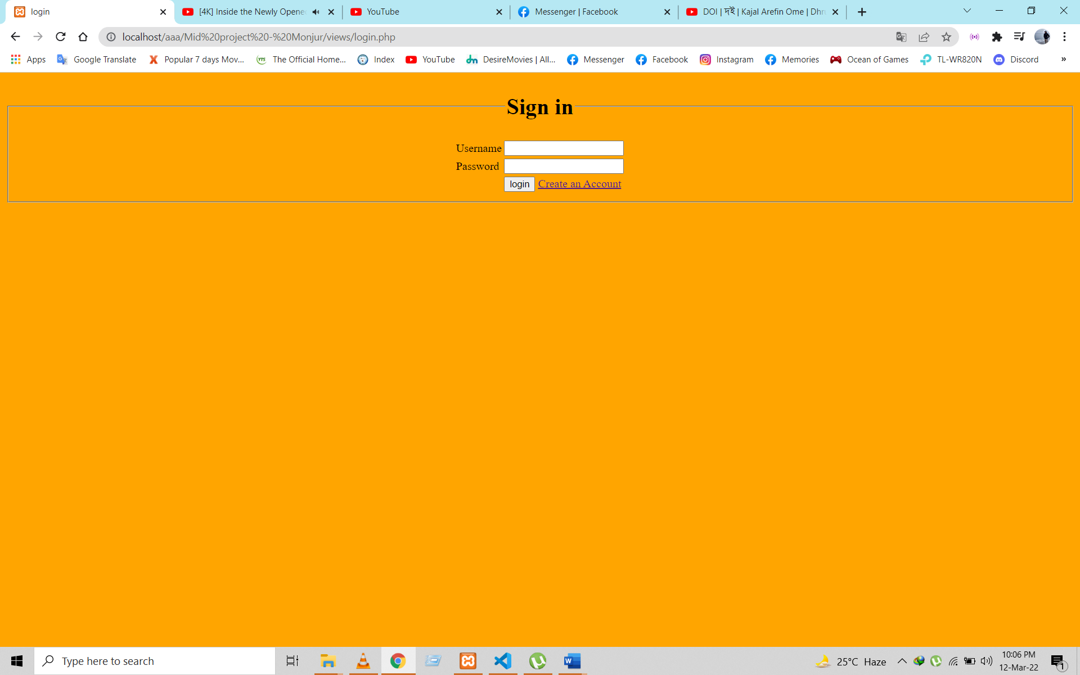

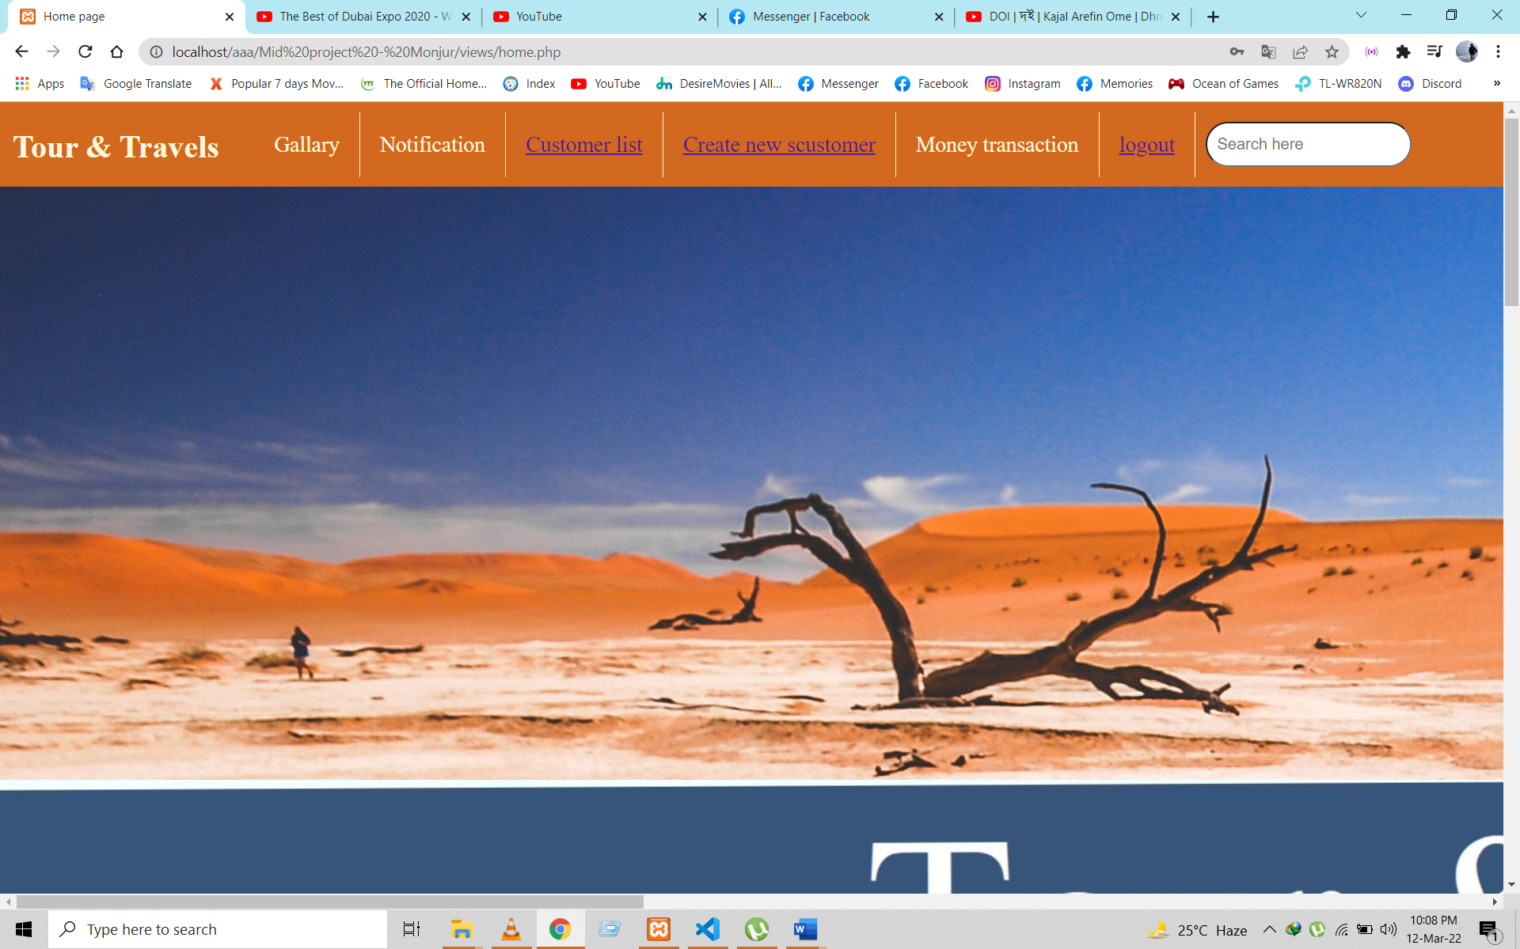

**Impact of this Project:**

Describe the increasing importance of your project on modern society and environment.

How will people be benefitted from your project?

The most significant advantage of a travel website is that it gives you a chance to present tour packages and sell them from your own platform. Due to an easy-to-manage website, you can post, manage, and publish tour packages.

4 Benefits of Using Online Travel Service over Local Travel Agent

* It saves time and money.
* The online guys provide expert insights and a safety net to your trip.
* It's easy to check out what people say about them.
* They can make your multi-destination holiday seamless.

**Limitations and Possible Future Improvements:**

**There may be some disadvantages to using online travel agents. These include:**

* Online travel agents can charge commission on every sale. This can range between 10-20 per cent of the gross cost.
* There may be restrictive terms and conditions imposed by OTAs such as guest cancellation and automatic room reselling policies.
* You may need to find a way of managing room availability across a range of OTAs, your own website, front desk and telephone sales. This can be time consuming and labour intensive. There are software options to help you manage this.
* Using OTAs does not reduce the need to have your own website with booking engine.
* You may still need to invest in a balanced multi-channel marketing strategy.

**Future Improvements:**

General Upcoming Tourism Trends. There are a variety of tourism trends that are based on more general changes in consumer behavior, like the need for healthy and organic food & drinks, sustainability, personalized service the rising demand for digitalization and the use of technology.

*[Note: Make sure that your report is maximum 10 pages (including cover page). Print (Colored) the report and submit it with spiral bind.]*

|  |  |  |  |  |  |
| --- | --- | --- | --- | --- | --- |
| CO1.1 and CO2.1 Evaluation: Project Report Evaluation | | | | | |
| Project Proposal  (5) | Background  Study  (5) | Requirement Analysis  (5) | Entity  Diagram  (5) | System Images  against the  Specification (5) | Total (25) |
|  |  |  |  |  |  |
|  | | | | | |